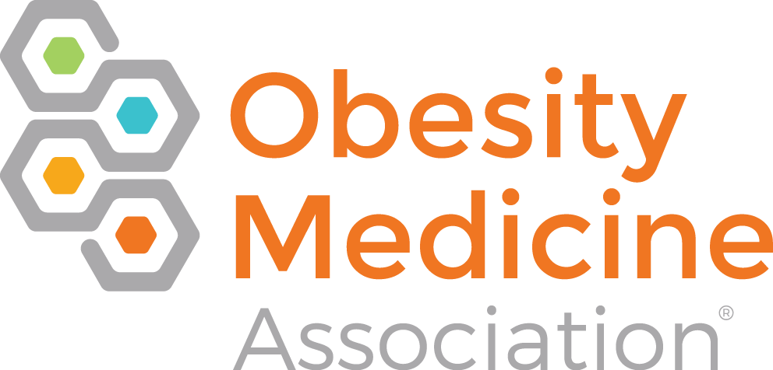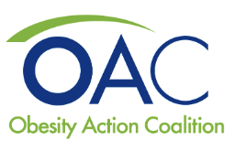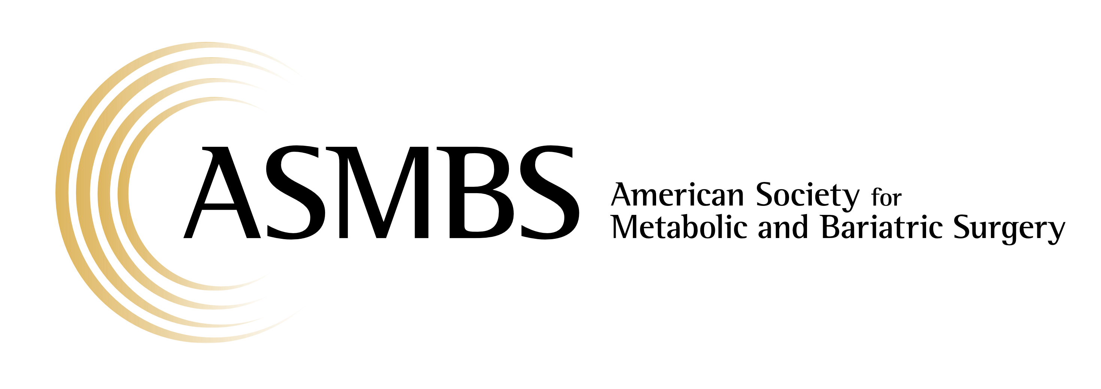

May 6, 2024

RE: Medicaid Coverage of FDA-Approved Obesity Medications

Dear Governor Youngkin and House Appropriations Committee Chair Torian and Vice Chair Sickles and Senate Finance and Appropriations Committee Chair Lucas,

On behalf of the Obesity Medicine Association (OMA), the American Society for Metabolic and Bariatric Surgery (ASMBS), The Obesity Society (TOS) and the Obesity Action Coalition (OAC), we are pleased that both the Governor and General Assembly have abandoned the previous budget plan that would have included arbitrary and unscientific restrictions on obesity care coverage.

Specifically, our organizations are deeply concerned that Virginia would have enshrined in statute BMI parameters for Medicaid coverage of FDA-approved obesity medications that are discriminatory and contrary to standard clinical guidelines -- leaving out many who also need and qualify for obesity treatment. We believe that all individuals should be treated with respect regardless of their weight or size and that those affected by the disease of obesity should have access to safe and effective treatment options in the same way that we treat other chronic diseases. Medical care decisions should be made between the healthcare provider and the patient.

Since 2013, when the American Medical Association adopted formal policy declaring obesity as a complex and chronic disease and supporting patient access to the full continuum of evidence-based obesity care, numerous federal and state policy organizations have echoed the AMA’s position. These include the National Council of Insurance Legislators, National Lieutenant Governors Association, National Hispanic Caucus of State Legislators, and the National Black Caucus of State Legislators, Veterans Health Administration, Indian Health Service, and the Federal Office of Personnel Management. And none of these organizations advocated for any of the arbitrary restrictions we are now seeing proposed in several state houses around the country.

Legislators too often apply a double standard when evaluating the cost/benefit of providing obesity care coverage compared to other chronic disease states – proposing laws that will preclude patients from receiving care until their obesity has progressed to a more severe stage. Examples include enacting medication coverage laws that are not in accordance with FDA label indications or writing into statute surgical coverage criteria that contradict the scientific guidelines established by clinical specialty societies.

Legislators must refrain from enacting draconian restrictions on obesity care that once written into law may never be repealed or alleviated. For example, the Texas legislature passed a law in 2009 mandating, among other discriminatory restrictions, a $5,000 deductible for state employees seeking metabolic/bariatric surgery – a major obstacle to care that is still in force today. For these reasons, we are pleased that Virginia policymakers have discarded a budget proposal that would have made Medicaid beneficiaries wait until their obesity had progressed to severe levels before they would have been allowed access to FDA-approved obesity medications.

Imagine requiring a cancer patient to delay treatment until their disease reached stage 3 or 4 or telling a patient with cardiovascular disease that they must have at least two major arterial blockages to receive cardiac catheterization. Such approaches would be viewed as immoral. Yet that is exactly what Virginia would have done if the state had adopted this approach toward obesity care coverage.

Legislators practicing medicine is never a good idea. Any restrictions on coverage should be done by state regulators, in consultation with healthcare providers and patients, to ensure implementation of reasonable eligibility criteria that can be reevaluated on an annual basis. Doing so will afford regulators the needed flexibility to develop policy solutions based on sound medical advice and real time conditions in the healthcare arena.

As you work together toward enacting a new fiscal year 2024-2025 budget, we strongly urge you to maintain Medicaid coverage for all obesity treatment avenues, including FDA-approved obesity medications to ensure that those in most need can continue to access the full range of obesity care.

Should you have any questions or need additional information, please feel free to contact our policy advisor Chris Gallagher via email at chris@potomaccurrents.com.

Sincerely,

Joe Nadglowski
President & CEO
Obesity Action Coalition

Teresa Fraker, FACHE, RN, CPHQ
Executive Director
Obesity Medicine Association

Anthony G. Comuzzie, Ph.D., FTOS
Chief Executive Officer
The Obesity Society

Diane M. Enos, MPH, RDN, CAE, FAND
Executive Director
American Society for Metabolic and Bariatric Surgery

